PROJECT DESIGN PHASE-II
TECHNOLOGY STACK (ARCHITECTURE & STACK)
Date
Team ID | SWTID-2026-3317 ______________________
Project Name | AI FAQ Assistant
Maximum Marks | 4 Marks

Technical Architecture
The AI FAQ Assistant uses a web-based presentation layer, a backend application/API layer, a MongoDB data layer and an external AI service. This architecture separates user interaction, business logic and data storage, making the application easier to develop, maintain and scale.
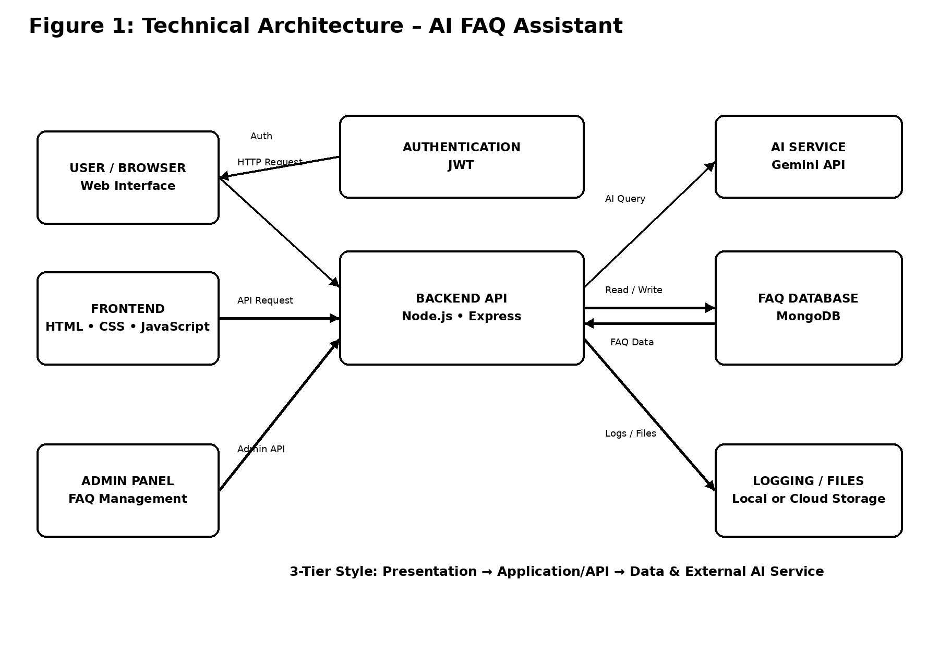
Figure 1: Technical Architecture and Data Flow of the AI FAQ Assistant

Table-1: Components & Technologies
S.No | Component | Description | Technology
1 | User Interface | Web interface through which users ask questions, view answers and access login/admin screens. | HTML, CSS, JavaScript / Bootstrap
2 | Application Logic-1 | Handles user requests, authentication, FAQ operations and API routing. | Node.js, Express.js
3 | Application Logic-2 | Processes natural-language questions and prepares responses using the AI service. | JavaScript / Node.js integration with Gemini API
4 | Application Logic-3 | Controls FAQ management, validation and role-based admin operations. | Express.js middleware and application services
5 | Database | Stores users, roles, FAQ questions, answers and related application records. | MongoDB / Mongoose
6 | Cloud Database | Optional cloud-hosted database for deployment and remote access. | MongoDB Atlas
7 | File Storage | Stores project assets, exported reports or uploaded files when required. | Local filesystem / Cloud object storage
8 | External API-1 | AI API used to process natural-language questions and generate relevant responses. | Google Gemini API
9 | External API-2 | Optional email/notification service for confirmation or system messages. | Email service API / SMTP
10 | Machine Learning Model | AI language model used for natural-language understanding and response generation. | Gemini generative AI model
11 | Infrastructure (Server / Cloud) | Runs the frontend/backend application during development or deployment. | Local Node.js server; optional cloud hosting such as Render/Railway/Vercel

Table-2: Application Characteristics
S.No | Characteristics | Description | Technology
1 | Open-Source Frameworks | Open-source tools provide the web interface, server-side API and database integration. | Node.js, Express.js, Bootstrap, Mongoose
2 | Security Implementations | Authentication uses JWT/session controls; passwords should be securely hashed; admin endpoints require authorization; input validation and secure environment variables are used. | JWT, bcrypt, HTTPS, input validation, OWASP practices
3 | Scalable Architecture | Presentation, application and data responsibilities are separated. Backend APIs can be scaled independently and MongoDB can support increasing data volume. | 3-tier architecture, Node.js/Express, MongoDB Atlas
4 | Availability | The application can be deployed on a reliable cloud platform and database service. Health checks and restart mechanisms can be added for production deployment. | Cloud hosting, MongoDB Atlas, health checks
5 | Performance | Use indexed FAQ fields, efficient database queries, validation and asynchronous API calls. Caching can be added for frequently requested FAQs as usage grows. | MongoDB indexes, Node.js async processing, optional Redis/CDN

References
- C4 model – Software architecture diagrams and system context concepts.
- IBM Developer – Architecture and application patterns.
- IBM Cloud Architecture – Cloud architecture concepts.
- AWS Architecture – Cloud architecture and scalability concepts.
- Medium – Technical architecture diagram guidance.
Note: The template date was written as “31 January 3035”; this document uses “31 January 2025” to match the dates in your other project-design documents.

